**Objectives**: I) Create tables using below given schema & DDL Scripts in Appendix A.

II) Load data into tables using csv files given in your classroom.

III) Run simple queries.

**Submission**: Each student team need to Upload a **single .pdf** file which will contain following things for all the queries listed in (III).

1. English query and SQL Query in the given sequence.
2. Screenshot of results.
3. Count of tuples in the results.
4. **Create tables using below given schema:** 
   1. Expand your Database => Open Query Tool window from Tool. or From SQL Shell.

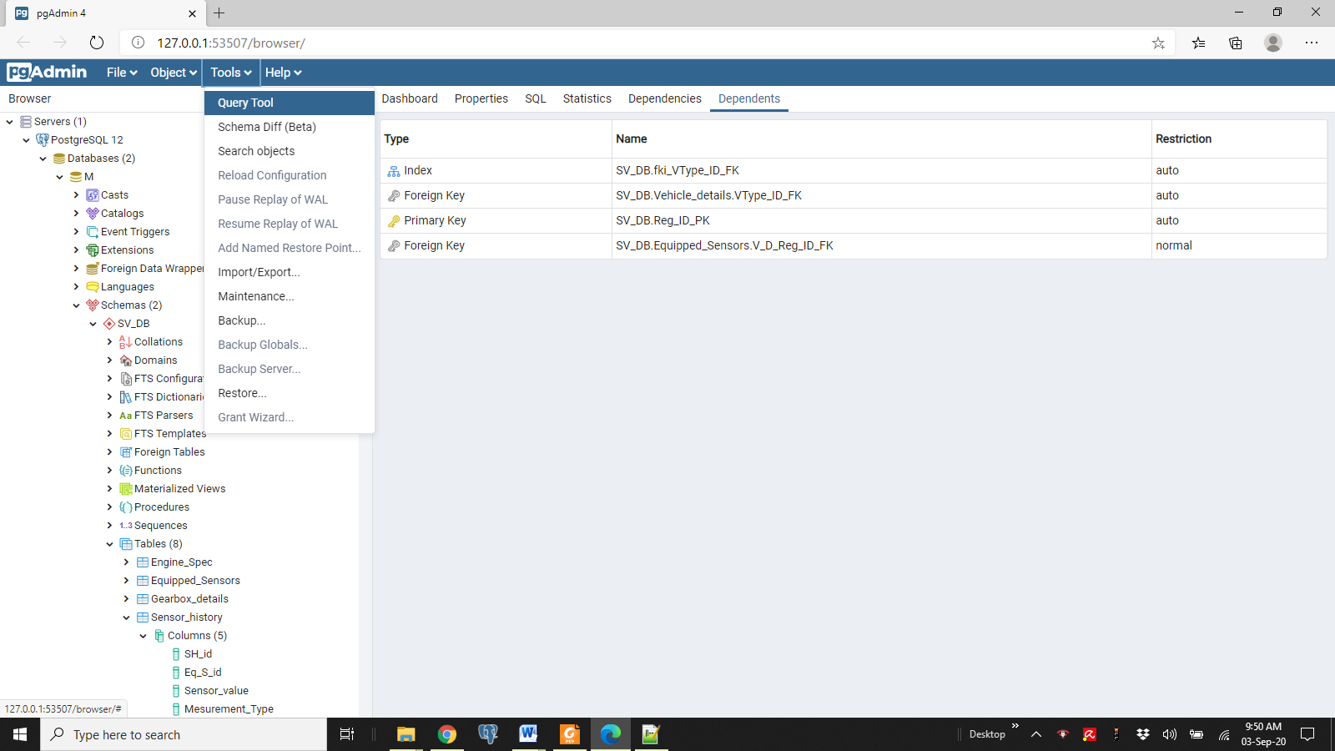

* 1. Type following to create Schema. –

**CREATE SCHEMA stock_DB;  
SET SEARCH_PATH TO stock_DB;**

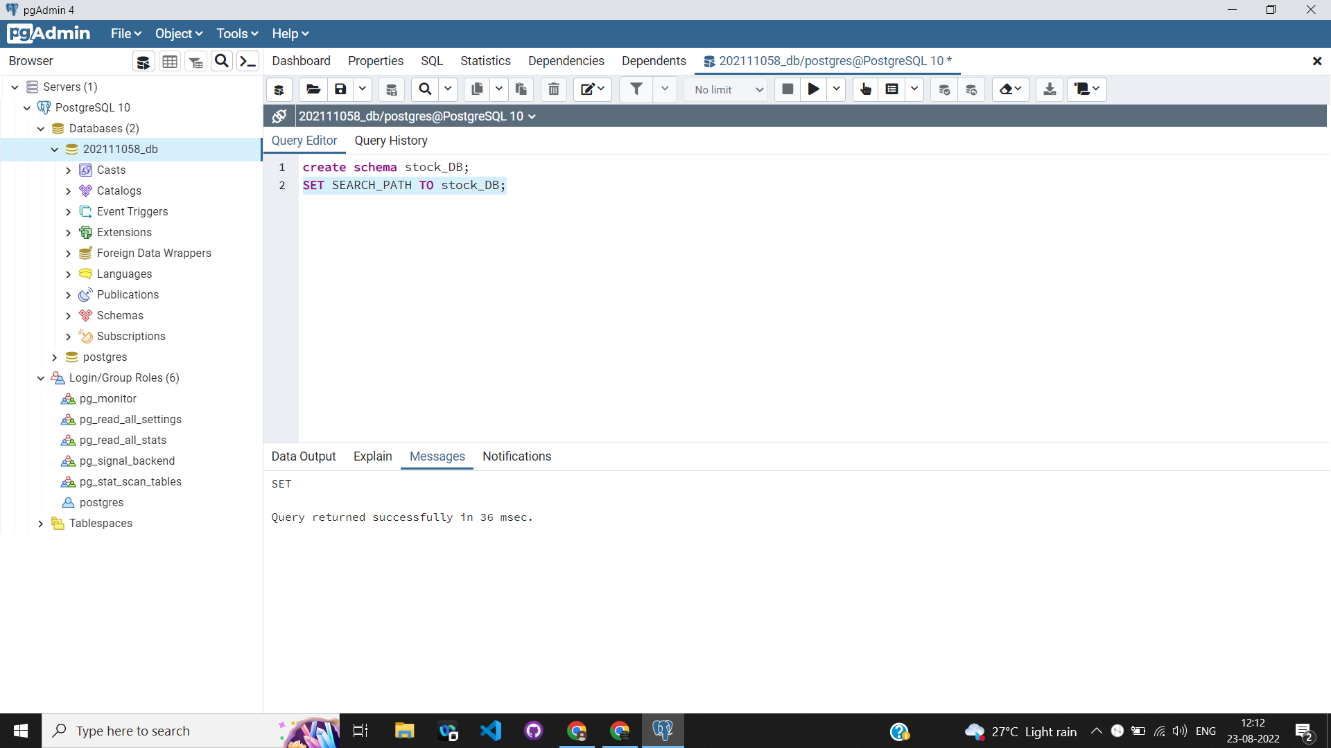

* 1. Table Schema Diagram. Find the DDL Scripts after the queries section III.

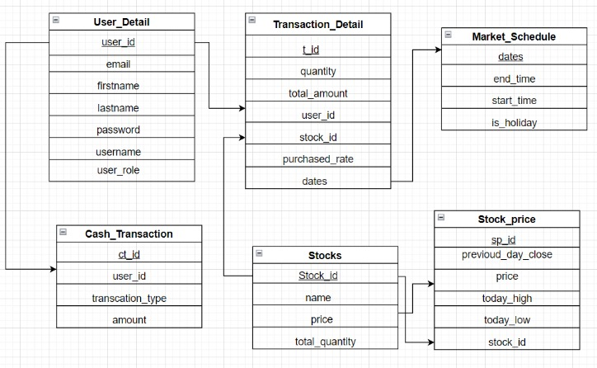

1. **Load data into tables using csv files given on classroom file.**

**COPY** stock_DB.User(user_id,email,firstname,lastname,username,password,user_role) FROM 'D:/lab1_dbms/user.csv' DELIMITER ',' CSV HEADER;

1. **Run queries.**
2. Show all user details.
3. List the names of stocks where the stock price is greater than 50$.
4. Show all the dates where there is no holiday.
5. Count the number of transactions where the amount is less than 300.
6. Find out average stock price.
7. Find out the highest stock price details.
8. Count all rows in market_schedule
9. List the names of stocks where the total quantity of stocks is less than 100.
10. Find out transactions whose transaction_type is credit
11. Find the stock details where the today's high is more than 100$.
12. find out stocks where price is greater than 500$ and quantity is greater than 50
13. Count the stock_id's where the pre close is greater then the today's high
14. Find out the detail of user whose first name is.paul
15. find the details of the cash transaction where the amount is between 100-200$.
16. Display record for the maximum total amount in transaction
17. Show admin’s details
18. Find username of user in ascending order of user_id for admin
19. Select details of top 2 highest stock price from stocks
20. Print count of different types of cash transactions
21. Print stock id and name whose price is greater than average of price value
22. Find stock names an ids whose price is greater than previous close
23. Find total quantity of stocks date wise whose transaction is done on particular date
24. Find stock name and price whose price is less than average price of today_low
25. Show table of user sorted email-wise
26. create view of maximum price
27. create a view for admin details then insert and display some new admin to the recently created view.
28. Create and display a view all the details of transactions whose type is debit (debit = false)
29. Display the sum of total amount transaction wise
30. Create a view with transaction made whose quantity is greater than average of all quantity in descending order of amount
31. Display all the transaction details done on holiday

**Appendix A: DDL Scripts to create tables.**

-----------------------------------------------------------------------------------------------------------------

CREATE TABLE IF NOT EXISTS stock_db."user"

(

user_id integer NOT NULL,

email character varying COLLATE pg_catalog."default",

firstname character varying COLLATE pg_catalog."default",

lastname character varying COLLATE pg_catalog."default",

username character varying COLLATE pg_catalog."default",

password bigint,

user_role boolean,

CONSTRAINT user_pkey PRIMARY KEY (user_id)

)

WITH (

OIDS = FALSE

)

TABLESPACE pg_default;

ALTER TABLE IF EXISTS stock_db."user"

OWNER to postgres;

—---------------------------------------------------------------------------------------------------------------------

CREATE TABLE IF NOT EXISTS stock_db.stocks

(

stock_id integer NOT NULL,

name character varying COLLATE pg_catalog."default",

price double precision,

quantity bigint,

CONSTRAINT stocks_pkey PRIMARY KEY (stock_id)

)

WITH (

OIDS = FALSE

)

TABLESPACE pg_default;

ALTER TABLE IF EXISTS stock_db.stocks

OWNER to postgres;

—---------------------------------------------------------------------------------------------------------------------

CREATE TABLE IF NOT EXISTS stock_db.market_schedule

(

dates date NOT NULL,

start_time time without time zone,

end_time time without time zone,

is_holiday boolean,

CONSTRAINT market_schedule_pkey PRIMARY KEY (dates)

)

WITH (

OIDS = FALSE

)

TABLESPACE pg_default;

ALTER TABLE IF EXISTS stock_db.market_schedule

OWNER to postgres;

—---------------------------------------------------------------------------------------------------------------------

CREATE TABLE IF NOT EXISTS stock_db.cash_transaction

(

ct_id bigint NOT NULL,

amount integer,

transaction_type boolean,

user_id integer,

CONSTRAINT cash_transaction_pkey PRIMARY KEY (ct_id),

CONSTRAINT "ct_user-id" FOREIGN KEY (user_id)

REFERENCES stock_db."user" (user_id) MATCH SIMPLE

ON UPDATE NO ACTION

ON DELETE NO ACTION

)

WITH (

OIDS = FALSE

)

TABLESPACE pg_default;

ALTER TABLE IF EXISTS stock_db.cash_transaction

OWNER to postgres;

—---------------------------------------------------------------------------------------------------------------------

CREATE TABLE IF NOT EXISTS stock_db.stock_price

(

sp_id bigint NOT NULL,

pre_close double precision,

price double precision,

today_high double precision,

today_low double precision,

stock_id bigint,

CONSTRAINT stock_price_pkey PRIMARY KEY (sp_id),

CONSTRAINT "stocks-stock_id" FOREIGN KEY (stock_id)

REFERENCES stock_db.stocks (stock_id) MATCH SIMPLE

ON UPDATE NO ACTION

ON DELETE NO ACTION

)

WITH (

OIDS = FALSE

)

TABLESPACE pg_default;

ALTER TABLE IF EXISTS stock_db.stock_price

OWNER to postgres;

—---------------------------------------------------------------------------------------------------------------------

CREATE TABLE IF NOT EXISTS stock_db.transaction_detail

(

t_id bigint NOT NULL,

quantity integer,

purchased_rate double precision,

total_amount numeric,

stock_id bigint,

user_id bigint,

date date,

CONSTRAINT transaction_detail_pkey PRIMARY KEY (t_id),

CONSTRAINT "market-dates" FOREIGN KEY (date)

REFERENCES stock_db.market_schedule (dates) MATCH SIMPLE

ON UPDATE NO ACTION

ON DELETE NO ACTION

NOT VALID,

CONSTRAINT "stocks-stock_id" FOREIGN KEY (stock_id)

REFERENCES stock_db.stocks (stock_id) MATCH SIMPLE

ON UPDATE NO ACTION

ON DELETE NO ACTION

NOT VALID,

CONSTRAINT "user-user_id" FOREIGN KEY (user_id)

REFERENCES stock_db."user" (user_id) MATCH SIMPLE

ON UPDATE NO ACTION

ON DELETE NO ACTION

NOT VALID

)

WITH (

OIDS = FALSE

)

TABLESPACE pg_default;